Name: Dodeja Yogesh Ghanshyambhai

Subject:HTML & CSS- Assignment

Faculty: Heet Modh

1.) Define The Terms: Website, Webpage, Web Browser, Web Server, HTML,

CSS?

* Website: A Website Is A Collection Of Many Web Pages, And Web Pages Are Digital Files That Are Written Using HTML(Hypertext Markup Language).
* Webpage: A Webpage Is A Document Written In HTML And Can Be Viewed On Any Web Browser. It Is Contained Within The Web Server, Which Can Be Accessed By Entering The URL For That Web Page, And Once It Is Loaded, It Appears On The User's Web Browser. Each Webpage Is Linked With A Unique URL; Hence Two Pages Cannot Have The Same URL.
* Web Browser: A Web Browser Is An Application Its Used To View Websites

For Example: Google Chrome,Microsoft Edge, Mozila Firefox

* Web Server: A Web Server Is A Dedicated Computer Responsible For Running Websites Sitting Out On Those Computers Somewhere On The Internet. They Are Specialized Programs That Circulate Web Pages As Summoned By The User. The Primary Objective Of Any Web Server Is To Collect, Process And Provide Web Pages To The Users.
* HTML: HTML Is Hyper Text Markup Language, Its Used To Make Web Pages, It Is Show Structure Of Web Pages.
* CSS: CSS Is Cascading Style Sheet, It Is Used To Design Web Pages And More Attractive Web Pages. Here Is Three Types Of Inline CSS , Internal CSS, External CSS.

2. Create a webpage to show “This is my first HTML page”

Code: <!DOCTYPE html>

<html lang="en">

<head>

    <meta charset="UTF-8">

    <meta http-equiv="X-UA-Compatible" content="IE=edge">

    <meta name="viewport" content="width= , initial-scale=1.0">

    <title>Document</title>

</head>

<body>

    <h1>This is my first HTML page</1>

</body>

</html>

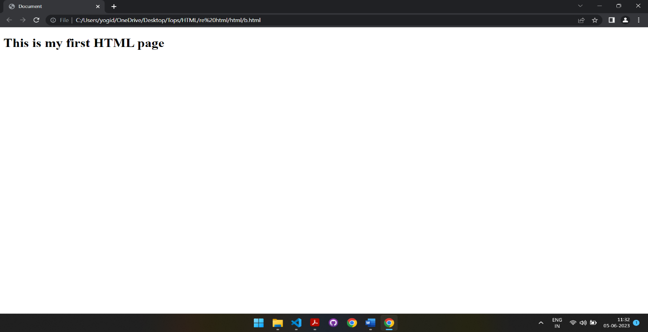

3. Display top 10 IT companies list in html webpage?

<!DOCTYPE html>

<html lang="en">

<head>

    <meta charset="UTF-8">

    <meta http-equiv="X-UA-Compatible" content="IE=edge">

    <meta name="viewport" content="width= , initial-scale=1.0">

    <title>Document</title>

</head>

<body>

    <ul>

        <li>Infosays</li>

        <li>HCL technologies</li>

        <li>Tech mahindra</li>

        <li>Wipro</li>

        <li>Hexaware Technologies</li>

        <li>Mindtree</li>

        <li>Sequato</li>

        <li>Mphasis</li>

        <li>Tata Consultancy Service</li>

        <li>eSparkBiz</li>

    </ul>

</body>

</html>

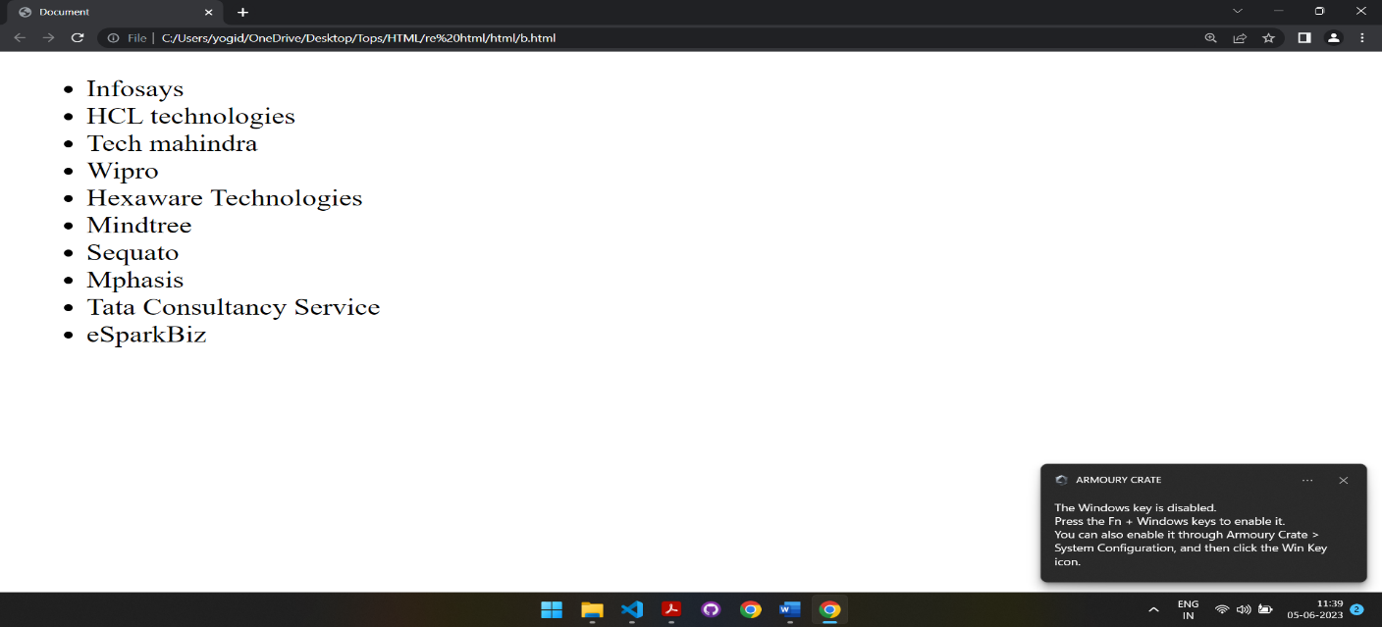

4. Create a dropdown list.

<!DOCTYPE html>

<html lang="en">

<head>

    <meta charset="UTF-8">

    <meta http-equiv="X-UA-Compatible" content="IE=edge">

    <meta name="viewport" content="width= , initial-scale=1.0">

    <title>Document</title>

</head>

<body>

<select name="" id="" >

    <option value="" selected disabled>Select</option>

    <option value="">Mangos</option>

    <option value="">Bananas</option>

    <option value="">Apple</option>

    <option value="">Oranges</option>

</select>

</body>

</html>

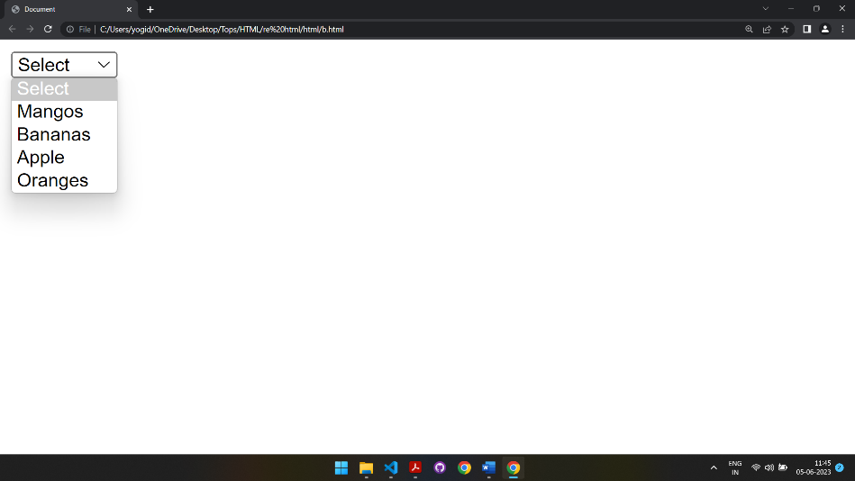

5. Create a Table Of college Management system using row span & col span.

6. Create below table using HTML table tags.

<!DOCTYPE html>

<html lang="en">

<head>

    <meta charset="UTF-8">

    <meta http-equiv="X-UA-Compatible" content="IE=edge">

    <meta name="viewport" content="width=device-width, initial-scale=1.0">

    <title>Table</title>

</head>

<body>

<table style="background-color: rgb(70, 212, 70) ;color: aqua;" border="1" >

    <tr>

        <td rowspan="5">0</td>

        <td style="background-color: red; color: bisque;">3</td>

        <td style="background-color: black; color: bisque;">6</td>

        <td style="background-color: red; color: bisque;">9</td>

        <td style="background-color: red; color: bisque;">12</td>

        <td style="background-color: black; color: bisque;">15</td>

        <td style="background-color: red; color: bisque;">18</td>

        <td style="background-color: red; color: bisque;">21</td>

        <td style="background-color: black; color: bisque;">24</td>

        <td style="background-color: red; color: bisque;">27</td>

        <td style="background-color: red; color: bisque;">30</td>

        <td style="background-color: black; color: bisque;">33</td>

        <td style="background-color: red; color: bisque;">36</td>

        <td>2to1</td>

    </tr>

      <tr>

        <td  style="background-color: black; color: bisque;">2</td>

        <td style="background-color: red; color: bisque;">5</td>

        <td  style="background-color: black; color: bisque;">8</td>

        <td  style="background-color: black; color: bisque;">11</td>

        <td style="background-color: red; color: bisque;">14</td>

        <td  style="background-color: black; color: bisque;">17</td>

        <td  style="background-color: black; color: bisque;"S>20</td>

        <td style="background-color: red; color: bisque;">23</td>

        <td  style="background-color: black; color: bisque;">26</td>

        <td  style="background-color: black; color: bisque;">29</td>

        <td style="background-color: red; color: bisque;">32</td>

        <td  style="background-color: black; color: bisque;">35</td>

        <td>2to1</td>

    </tr>

      <tr>

        <td style="background-color: red; color: bisque;">1</td>

        <td style="background-color: black; color: bisque;">4</td>

        <td style="background-color: red; color: bisque;">7</td>

        <td  style="background-color: black; color: bisque;">10</td>

        <td  style="background-color: black; color: bisque;">13</td>

        <td style="background-color: red; color: bisque;">16</td>

        <td style="background-color: red; color: bisque;">19</td>

        <td  style="background-color: black; color: bisque;">22</td>

        <td style="background-color: red; color: bisque;">25</td>

        <td  style="background-color: black; color: bisque;">28</td>

        <td  style="background-color: black; color: bisque;">31</td>

        <td style="background-color: red; color: bisque;">34</td>

        <td>2to1</td>

   <tr>

        <td colspan="4">1st12</td>

         <td colspan="4">2nd12</td>

        <td colspan="4">3rd12</td>

    </tr>

    <tr >

        <td colspan="2">1to18</td>

         <td colspan="2">Even</td>

        <td colspan="2" bgcolor="red"></td>

        <td colspan="2" bgcolor="black"></td>

        <td colspan="2">OOD</td>

        <td colspan="2">19to36</td>

    </tr>

</table>

</body>

</html>

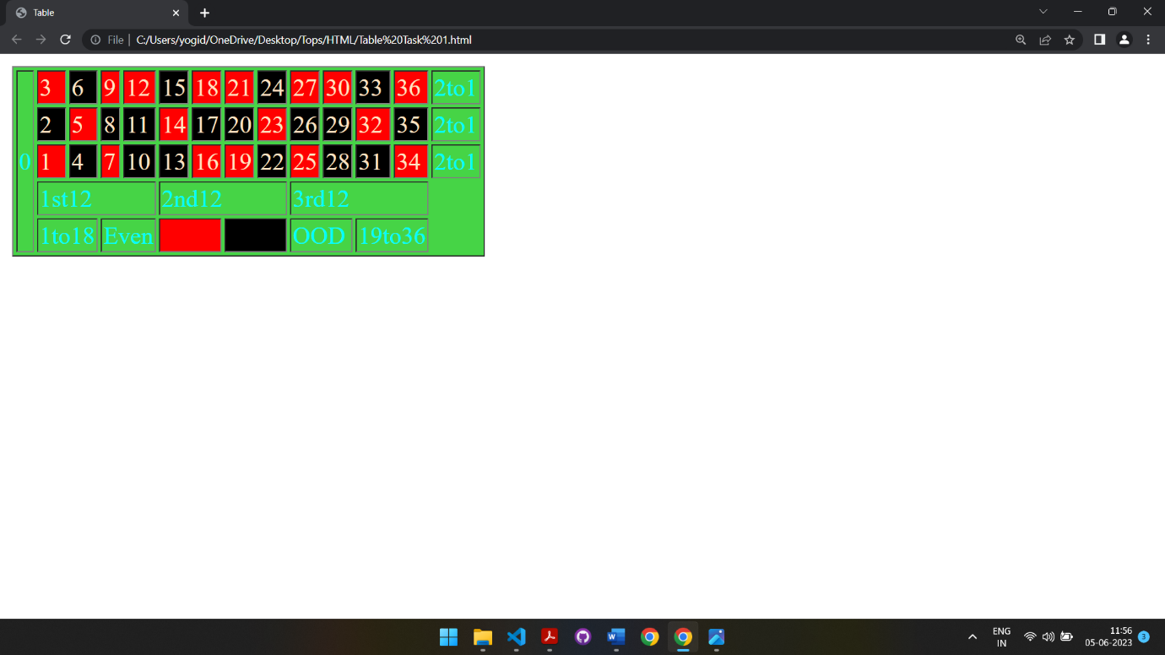

7. Create Registration form using HTML, CSS

<!DOCTYPE html>

<html lang="en">

<head>

  <meta charset="UTF-8">

  <meta http-equiv="X-UA-Compatible" content="IE=edge">

  <meta name="viewport" content="width=device-width, initial-scale=1.0">

  <title>Document</title>

  <style>

    table {

      height: 550px;

      width: 450px;

      background: yellowgreen;

      text-align: center;

      margin-left: 550px;

      font-family: sans-serif;

    }

  </style>

</head>

<body>

  <h3>

    <center>Registration form</center>

  </h3>

  <table border="1">

    <form action="">

      <tr>

        <td align="center">Enter Your First <br> Name</td>

        <td><input type="text" name="" id=""></td>

      <tr>

        <td align="center">Enter Your Last <br> name</td>

        <td><input type="text" name="" id="">

      </tr>

      <tr>

        <td align="center">Enter Your <br> Password</td>

        <td><input type="password" name="" id=""></td>

      </tr>

      <tr>

        <td>Re-Enter Your Password</td>

        <td><input type="password" name="" id=""></td>

      </tr>

      <tr>

        <td>Enter Your Email id</td>

        <td> <input type="email" name="" id=""></td>

      </tr>

      <tr>

        <td>Enter Your Mobile no</td>

        <td> <input type="text" name="" id=""></td>

      </tr>

      <tr>

        <td>Enter Your Address</td>

        <td> <textarea name="" id="" cols="30" rows="10"></textarea></td>

      </tr>

      <tr>

        <td>Select Your Gender</td>

        <td><input type="radio" name="xyz" id="xyz"> Male

          <input type="radio" name="xyz" id="xyz"> Female

        </td>

      </tr>

      <tr>

        <td>Select Your Hobbies</td>

        <td><input type="radio" name="" id=""> Hobby1

          <input type="radio" name="" id=""> Hobby2

          <input type="radio" name="" id="">Hobby3

        </td>

      </tr>

      <tr>

        <td>Enter Your DOB</td>

        <td><input type="date" name="" id=""></td>

      </tr>

      <tr>

        <td align="center">Select Your <br> Country</td>

        <td>

          <select name="" id="">

            <option value="" selected="selectected" disabled="disabled">Select Your Country</option>

            <option value="">India</option>

            <option value="">Pakistan</option>

            <option value="">Afghanistan</option>

          </select>

      <tr>

        <td>Upload Your Photo</td>

        <td> <input type="file" name="" id=""></td>

      </tr>

      <tr colspan="2">

        <td></td>

        <td> <input type="submit" name="" value="Save my data">

          <input type="submit" name="" value="Reset data">

        </td>

      </tr>

      </td>

      </tr>

      </tr>

    </form>

  </table>

</body>

</html>

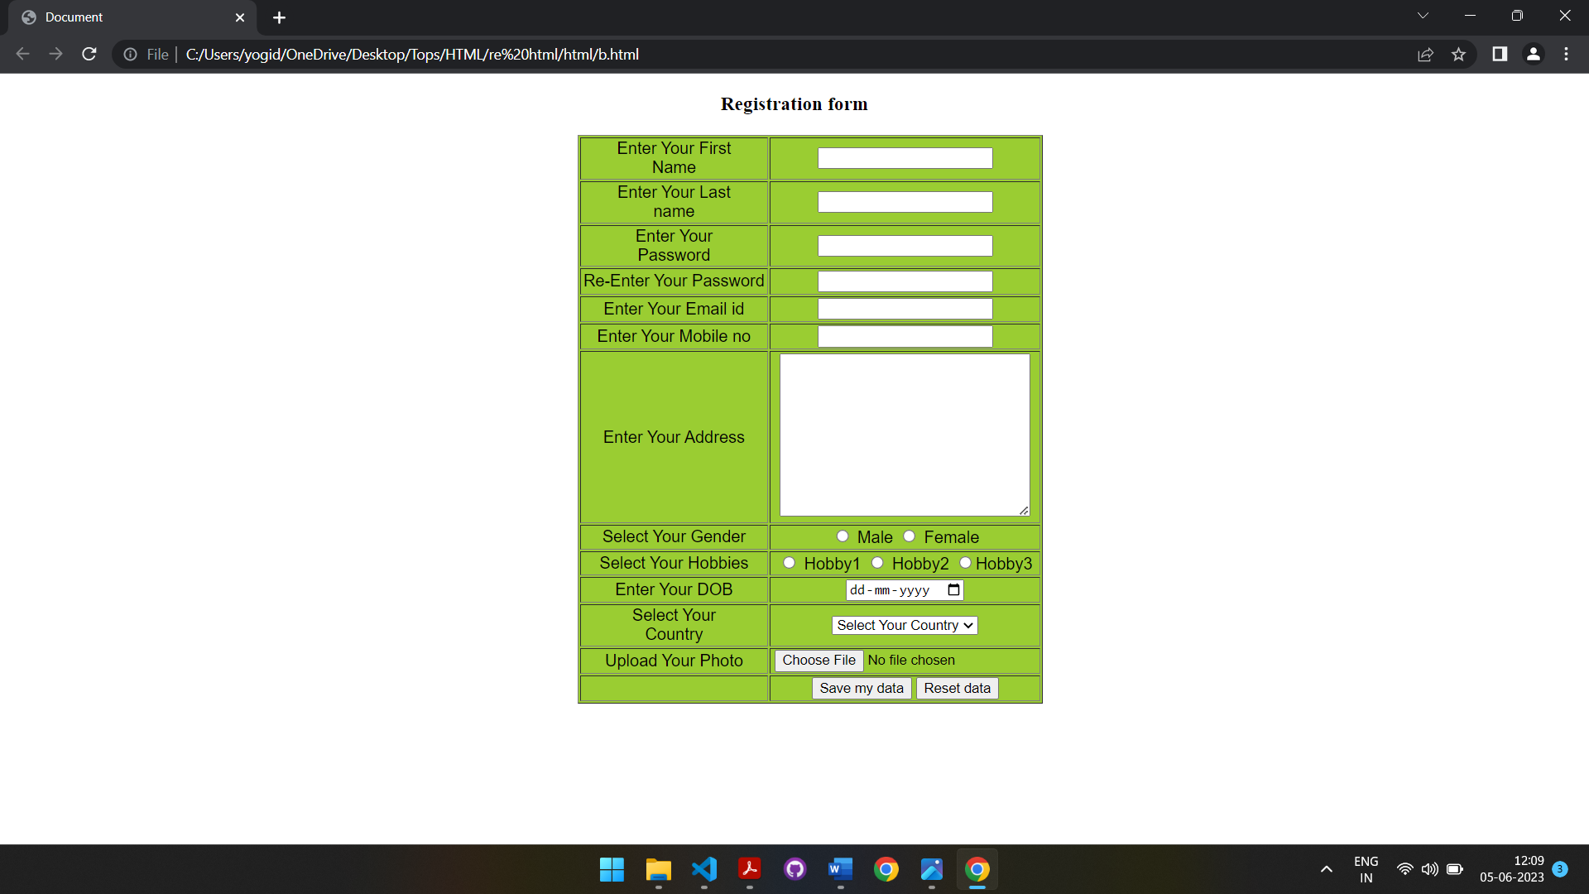

8. In how many ways can a CSS be integrated as a web page?

* CSS can be integrated three types:
* Inline CSS
* Internal CSS
* External CSS

9. Which Property Controls The Image Scroll In The Background?

* In The Background-Attachment Property We Can Use Fixed,Local,Scroll Cantrols Are Used In Image Control Background

Ex: Body{

Background-Repeat: No-Repeat;

Background- Attatchment: Fixed;

}

10 Why Should Background And Color Be Used As Separate Properties?

* Background Color Is Using To Change Background Color Of Text And Color Is Uses Only Text Color Of Text

<!DOCTYPE Html>

<Html Lang="En">

<Head>

    <Meta Charset="UTF-8">

    <Meta Http-Equiv="X-UA-Compatible" Content="IE=Edge">

    <Meta Name="Viewport" Content="Width=Device-Width, Initial-Scale=1.0">

    <Title>Document</Title>

    <Style>

        P{

            Background-Color: Blue;

            Color:Darkmagenta !Important;

        }

        A:Link{

            Color: Aqua;

            Background-Color: Gray;

        }

        A:Visited{

            Color: Blueviolet;

            Background-Color: White;

        }

        A:Hover{

            Color: Green;

            Text-Decoration: None;

        }

        A:Active{

            Color: Brown;

        P::First-Letter{

            Font-Size: 20px;

            Color: Red;

        }

        P::Selection{

            Background-Color: Black;

            Color: White;

        }

    </Style>

</Head>

<Body>

    <Input Type="Text" Name="" Id="">

    <A Href="#">Home</A>

    <Input Type="Number" Name="" Id="" Min="0" Max="5">

    <P Style="Color: Cadetblue;">Lorem Ipsum Dolor Sit Amet Consectetur Adipisicing Elit. In Necessitatibus At Expedita Sint, Maxime Dicta Ipsa Quaerat Sunt Similique Facere Quis Repellat Quam Illo Culpa Dignissimos Iusto Consequatur Deleniti Corrupti?</P>

    </Div>

</Body>

</Html>

11 How To Center Block Elements Using CSS1?

* Text-Align: Center;

Ex: <P Style="Text-Align: Center;">Lorem Ipsum Dolor Sit Amet Consectetur Adipisicing Elit. Tempore A Veniam, Quos Perspiciatis Aut Nihil Dolorem Minus Option</P>

12. How To Maintain The CSS Specifications?

* The CSS Specifications Maintained By W3C (World Wide Web Consoritum)
* The Latest Version Of CSS Is CSS3
* Use Comments In Your CSS Code Then Find The Other Devlopers To Understand Your Code And Easily Maintain

13. What Are The Ways To Integrate CSS As A Web Page?

There Are Three Types Of Css

* Internal CSS
* Inline CSS
* External CSS

1.) Internal CSS    <Style>

        P{

            Color: Blue;

        }

    </Style>

</Head>

<Body>

<P>

    Hello HOW ARE YOU?

</P>

2.)Inline CSS <P Style="Color: Blueviolet;">

    Hello HOW ARE YOU?

</P>

3.) External CSS:

 <Style>

        P{

            Color: Blue;

        }

    </Style>

14. What Is Embedded Style Sheets?

* In The Embedded Stylesheet Using The <Style>…</Style> Element
* We Do This Embedding Stylesheet Information Within Style Tag

   <Style>

        .One{

            Background-Color: Yellow;

        }

        .Two{

            Background-Color: Blue;

        }

        .Three{

            Background-Color: Red;

        }

        .Four{

            Background-Color: Gray;

            Box-Shadow: 10%;

        }

    </Style>

15 What Are The External Style Sheets?

* It Is A Seprerat CSS File Created By Link Within Head Section Of CSS
* <Link Rel="Stylesheet" Href="Style.Css"

        .One {

            Background-Color: Yellow;

        }

        .Two {

            Background-Color: Blue;

        }

        .Three {

            Background-Color: Red;

        }

        .Four {

            Background-Color: Gray;

            Box-Shadow: 10%;

      }

16 What Are The Advantages And Disadvantages Of Using External Style Sheets?

* Advantages Of External CSS

- Using Them, The Styles Of Multiple Documents Can Be Controlled From One File.

- Classes Can Be Created For Use On Multiple HTML Element Types In Many Documents.

- In Complex Situations, Selector And Grouping Methods Can Be Used To Apply Styles.

* The Disadvantages Of External Style Sheets Are:

- In Order To Import Style Information For Each Document, An Extra Download Is Needed.

- Until The External Style Sheet Is Loaded, It May Not Be Possible To Render The Document.

- For Small Number Of Style Definitions, It Is Not Viable.

17 What Is The Meaning Of The CSS Selector?

1.Group H1 , H2 , H3{}

2.Single H1{}

3.Universal \*{}

4. Class .One{}

5. Id #One{}

\*{

Margin: 0;

Padding: 0;

Box-Sizing: Border-Box;

}

.Main{

Height: 470px;

Width: 100%;

Background-Image:Radial-Gradient(Green , Green);

}

#Main{

Height: 470px;

Width: 100%;

Background-Image:Radial-Gradient(Green , Green);

}

H1{

Color : White;

}

H1,H2{

Color : White;

}

18 What Are The Media Types Allowed By CSS?

* All
* Print
* Speech
* Screen
* Width And Height Of The Viewport
* Width And Height Of The Device
* Orientation And Resoluationss

320px — 480px: Mobile Devices.

481px — 768px: Ipads, Tablets.

769px — 1024px: Small Screens, Laptops.

1025px — 1200px: Desktops, Large Screens.

1201px And More — Extra Large Screens, TV

19 What Is The Rule Set?

* A CSS Rule Set Contains One Or More Selectors And One Or More Declarations
* The Selector, Which In This Example Is H1,Points To An HTML Element.
* In This Example, The Declaration Is Blue And Text Align Center Styles The Elements With Property And Value
* The Declaration, Which In This Example Are Color: Blue And Text Align: Center Style The Element With Property And Value

20 Create Layouts

HTML:

<Body>

    <!-- Main Div Start -->

    <Div Class="Body">

        <!-- Div 1 Start -->

        <Div Id="Bodi">

            <!-- Div 2 Start -->

            <Div Class="One">

                <!-- Div 3 Start -->

                <Div Class="Aone">Thumbnail</Div>

                <!-- Div 4 Start -->

                <Div Class="Aaone">This Is Wider Card With Wporting Text Below As Natural Lead In To Additional

                    Content.This Content Is A Little

                    <Input Type="Submit" Name="" Id="" Value="View">

                    <Input Type="Submit" Name="" Id="" Value="Edit">

                    <!-- Div 3 End -->

                </Div>

                <!-- Div 4 End -->

            </Div>

            <!-- Div 5 Start -->

            <Div Class="Two">

                <!-- Div 6 Start -->

                <Div Class="Atwo">Thumbnail</Div>

                <!-- Div 7 Start -->

                <Div Class="Aatwo">This Is Wider Card With Wporting Text Below As Natural Lead In To Additional

                    Content.This Content Is A Little

                    <Input Type="Submit" Name="" Id="" Value="View">

                    <Input Type="Submit" Name="" Id="" Value="Edit">

                    <!-- Div 6 End -->

                </Div>

                <!-- Div 7 End -->

            </Div>

            <!-- Div 8 Start -->

            <Div Class="Three">

                <!-- Div 9 Start -->

                <Div Class="Athree">Thumbnail</Div>

                <!-- Div 10 Start -->

                <Div Class="Aathree">This Is Wider Card With Wporting Text Below As Natural Lead In To Additional

                    Content.This Content Is A Little

                    <Input Type="Submit" Name="" Id="" Value="View">

                    <Input Type="Submit" Name="" Id="" Value="Edit">

                    <!-- Div 9 End -->

                </Div>

                <!-- Div 10 End -->

            </Div>

            <!-- Div 11 Start -->

            <Div Class="Four">

                <!-- Div 12 Start & End -->

                <Div Class="Afour">Thumbnail</Div>

                <!-- Div 13 Start -->

                <Div Class="Aafour">This Is Wider Card With Wporting Text Below As Natural Lead In To Additional

                    Content.This Content Is A Little

                    <Input Type="Submit" Name="" Id="" Value="View">

                    <Input Type="Submit" Name="" Id="" Value="Edit">

                    <!-- Div 13 End -->

                </Div>

                <!-- Div 14 Start -->

                <Div Class="Five">

                    <!-- Div 16 Start -->

                    <Div Class="Afive">Thumbnail</Div>

                    <!-- Div 17 Start -->

                    <Div Class="Aafive">This Is Wider Card With Wporting Text Below As Natural Lead In To Additional

                        Content.This Content Is A Little

                        <Input Type="Submit" Name="" Id="" Value="View">

                        <Input Type="Submit" Name="" Id="" Value="Edit">

                        <!-- Div 16 End -->

                    </Div>

                    <!-- Div 17 End -->

                </Div>

                <!-- Div 18 Start -->

                <Div Class="Six">

                    <!-- Div 19 Start & End -->

                    <Div Class="Asix">Thumbnail</Div>

                    <Div Class="Aasix">This Is Wider Card With Wporting Text Below As Natural Lead In To Additional

                        Content.This Content Is A Little

                        <Input Type="Submit" Name="View" Id="" Value="View">

                        <Input Type="Submit" Name="View" Id="" Value="Edit">

                    </Div>

                    <!-- Div 2 End -->

                </Div>

                <!-- Div 1 End -->

            </Div>

            <!-- Main Div End -->

        </Div>

</Body>

CSS: <!-- CSS -->

    <Style>

        .Body {

            Height: 800px;

            Width: 100%;

            Background-Color: Gray;

        }

        #Bodi {

            Height: 800px;

            Width: 70%;

            Background-Color: Aquamarine;

            Margin: 0 0 0px 390px;

            Display: Flex;

        }

        .One {

            Height: 300px;

            Width: 300px;

            Background-Color: Blueviolet;

        }

        .Aone {

            Height: 200px;

            Width: 300px;

            Background-Color: Rgba(0, 0, 0);

            Color: White;

            Align-Items: Center;

            Justify-Content: Center;

            Display: Flex;

        }

        .Aaone {

            Height: 100px;

            Width: 300px;

            Background-Color: Rgb(253, 253, 253);

        }

        .Two {

            Height: 300px;

            Width: 300px;

            Background-Color: Blueviolet;

            Margin: 0 0 0 50px;

        }

        .Atwo {

            Height: 200px;

            Width: 300px;

            Background-Color: Rgb(0, 0, 0);

            Color: White;

            Text-Align: Center;

            Align-Items: Center;

            Display: Flex;

            Justify-Content: Center;

        }

        .Aatwo {

            Height: 100px;

            Width: 300px;

            Background-Color: Rgb(250, 252, 248);

        }

        .Three {

            Height: 300px;

            Width: 300px;

            Background-Color: Blueviolet;

            Margin: 0 0 0 50px;

            Text-Align: Center;

        }

        .Athree {

            Height: 200px;

            Width: 300px;

            Background-Color: Rgb(0, 0, 0);

            Color: White;

            Text-Align: Center;

            Align-Items: Center;

            Justify-Content: Center;

            Display: Flex;

            Justify-Content: Center;

        }

        .Aathree {

            Height: 100px;

            Width: 300px;

            Background-Color: Rgb(249, 255, 243);

            Text-Align: Center;

        }

        .Four {

            Height: 300px;

            Width: 300px;

            Background-Color: Blueviolet;

            Margin: 350px 0 0 -1000px;

        }

        .Afour {

            Height: 200px;

            Width: 300px;

            Background-Color: Rgb(0, 0, 0);

            Color: White;

            Text-Align: Center;

            Text-Align: Center;

            Align-Items: Center;

            Justify-Content: Center;

            Display: Flex;

            Justify-Content: Center;

        }

        .Aafour {

            Height: 100px;

            Width: 300px;

            Background-Color: Rgb(248, 248, 248);

        }

        .Five {

            Height: 300px;

            Width: 300px;

            Background-Color: Blueviolet;

            Margin: -300px 100px 100px 350px;

        }

        .Afive {

            Height: 200px;

            Width: 300px;

            Background-Color: Rgb(0, 0, 0);

            Color: White;

            Text-Align: Center;

            Text-Align: Center;

            Align-Items: Center;

            Justify-Content: Center;

            Display: Flex;

            Justify-Content: Center;

        }

        .Aafive {

            Height: 100px;

            Width: 300px;

            Background-Color: Rgb(251, 255, 245);

        }

        .Six {

            Height: 300px;

            Width: 300px;

            Background-Color: Blueviolet;

            Margin: -400px 0 0 700px;

        }

        .Asix {

            Height: 200px;

            Width: 300px;

            Background-Color: Rgb(0, 0, 0);

            Color: White;

            Text-Align: Center;

            Text-Align: Center;

            Align-Items: Center;

            Justify-Content: Center;

            Display: Flex;

            Justify-Content: Center;

        }

        .Aasix {

            Height: 100px;

            Width: 300px;

            Background-Color: Rgb(251, 255, 245);

        }

    </Style>

Output:

